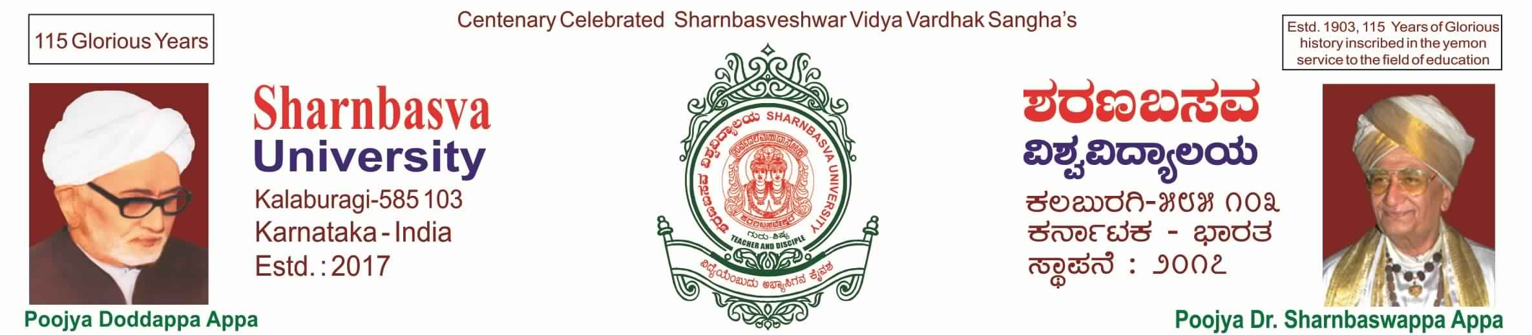

A

PROJECT REPORT

ON

“E-LEARNING”

*Submitted in partial fulfillment of the requirement for the award of*

**BACHELOR OF TECHNOLOGY IN**

**COMPUTER SCIENCE & ENGINEERING,**

**SHARNBASVA UNIVERSITY KALABURAGI**

Submitted by

K GAUTAM (SG20CSE059)

RAMKUMAR (SG20CSE105)

ROHIT S KELAMANI (SG20CSE112)

MOHAMMAD SOOFI SARMAST (SG20CSE080)

**UNDER THE GUIDENCE OF**

Prof. **BASWANTHRAO PATIL**



CERTIFICATE

This is to certify that

K GAUTAM (SG20CSE059)*,* RAMKUMAR (SG20CSE105)*,* ROHIT S KELAMANI (SG20CSE112)*,* MOHAMMAD SOOFI SARMAST (SG20CSE080) of I Semester has delivered the project on “E-LEARNING” for partial fulfillment of Bachelor of technology in Computer Science and Engineering, SHARNBASVA UNIVERSITY KALABURAGI during the academic year 2020-2021.

Guide Head of Department Principal

ACKNOWLEDGEMENT

We express our deep sense of gratitude to our esteemed “SHARNBASVA UNIVESITY” KALABURGI which has provided us an opportunity to fulfill the most cherished desire to reach our goal.

We also extend our sincere thanks to D**r**. ANILKUMAR G BIDVE, Registrar, Sharnbasva university, for his constant encouragement.

We would like to express our sense of gratitude to our beloved Dr. BASAVARAJ S MATHAPATI Dean for providing the right academic climate at this university that has made this entire task appreciate.

We are thankful to Prof. SHARANABASAPPA A MADIVAL Chairman, department of computer science & engineering, for giving permission to carry out this project in the university.

We wish to place our grateful thanks to our project guide Prof. BASAWANTHRAO PATIL without their help and guidance, it would not have been possible to complete this project work.

Finally, we express our grateful thanks to all our staff members of our department, who helped us a lot in the completion of project directly or indirectly within the schedule period.

K GAUTAM (SG20CSE059)

RAMKUMAR (SG20CSE105)

ROHIT S KELAMANI (SG20CSE112)

MOHAMMAD SOOFI SARMAST (SG20CSE080)